Matt Snyder
Springboard Data Science Career Track
11/7/2025
Guided Capstone Project Report – Big Mountain Resort
Big Mountain Resort recently invested $1.5M in new chairlifts and seeks to determine whether its weekend ticket prices are aligned with market trends. This analysis uses U.S. ski resort data to identify which features most influence pricing and to provide data-driven recommendations for revenue optimization.
The dataset that was used includes ~300 U.S. ski resorts with features including vertical drop, skiable acreage, number of lifts, snowmaking acreage, and region/state. Our target variable is ‘AdultWeekend’ (weekend ticket price in USD), as it reflects the peak demand period and is most representative and comparable measure to a resort’s pricing strategy.
We cleaned the dataset by correcting major outliers, notably in ‘SkiableTerrain_ac’ and ‘yearsOpen’ where incorrect numerical figures were put in which significantly skewed the dataset (e.g., Skiable terrain acreage had total acreage of the resort entered instead of their actual skiable area only. One resort had put ~2019 in the amount of years open, which was an entry error where the calendar year was entered instead). During preprocessing, we scaled numeric features so we could compare them equally against other features. Moreover, we encoded categorical features using OneHotEncoder with a Pipeline, which turned the categorical features’ values to 0s or 1s (implying that the resort does not have or has the said amenity).

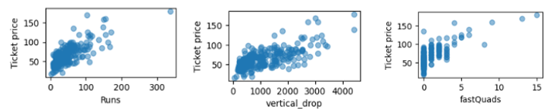
Figure 1. Relationships between resort features (Runs, Vertical Drop, and Fast Quads) and weekend ticket price.

The above figure (Figure 1) shows a sample of scatterplots that were shown to have a direct correlation with ticket price.
For models tested, we used a multiple linear regression as a baseline and a random forest regressor (RFR), which became our final model due to its smaller error rate and higher R^2. Our model performance had an R^2 test score of .76 and a Mean Absolute Error (MAE) of ~$11.8. We found that this captures nonlinear interactions more effectively than the linear baseline.

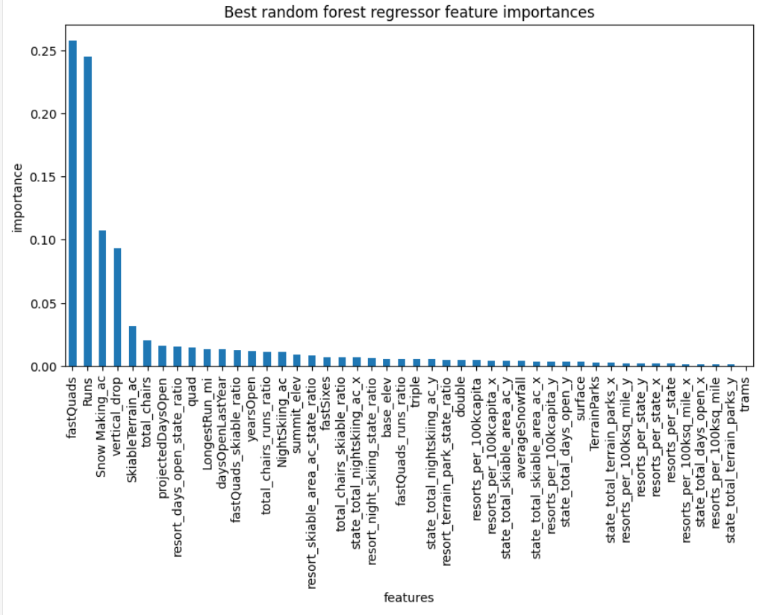
Figure 2. Feature Importance values from the Random Forest Model.

From the RFR model outputs, we found that resort size (vertical drop & skiable acreage), terrain (vertical drop & number of runs), and lift quality (number of quads) were key indicators of higher pricing.
The model predicted Big Mountain’s fair-market weekend ticket price at $93.48, about ~$12 higher than its current price. With a MAE of 10.40, we can safely raise the ticket price by $2-5, although a slow rollout is recommended and tested during peak holidays. To cover the $1.5M operating expense increase, we recommend adding length to the vertical drop and a ski lift to accompany it. Model projections suggest that adding vertical terrain and a corresponding lift could raise annual revenue by approximately $1.6M, assuming improvements drive proportional increases in perceived value and visitation.
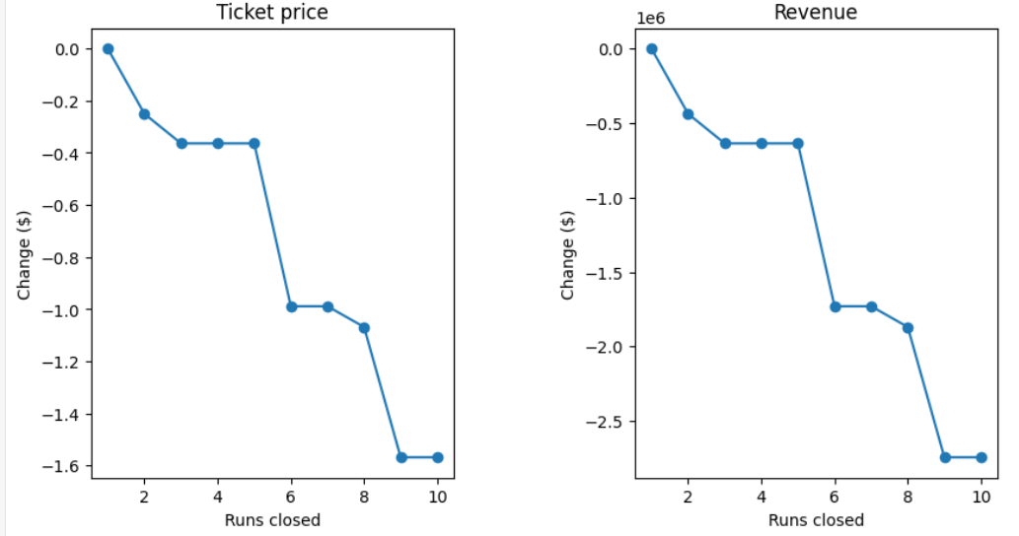
Figure 3. Predicted revenue impacts under potential ski run reduction scenarios.
Lastly, getting rid of 10 runs (as it was one of the given strategies) showed a significant loss in the millions of dollars; however, disposing of 3-5 runs was forecasted to lose $0.40 per ticket, which would total to ~$600k per annum. If this strategy was to be executed, a cost-savings analysis would need to be conducted often to see if the cost savings outweigh the revenue loss (see Figure 3).

In conclusion, Big Mountain’s pricing is competitive but slightly conservative given its scale and lift infrastructure. Continued upgrades to terrain features and lift systems would support premium positioning.

